

SUBJECT NAME: MODELLING OF FLUID POWER COMPONENTS

SUBJECT CODE: IHA 2609

PROJECT BASED ON MODELLING OF A HYDRAULIC CIRCUIT.

PROJECT MEMBERS:

* LAKSMI BANGALORE GANGADHARASWAMY
* SANKEERTH SHIVAKUMAR
* PALLAB GANGULY

Contents

INTRODUCTION: 3

MODELLING OF INDIVIDUAL COMPONENTS 4

VERIFICATION OF THE MODEL 14

CONTROLLER TUNING…………………………………………………………………………………………………………21

CONCLUSION…………………………………………………………………………………………………………………..24

Figure 1/SUBSYSTEM OF A SIMULINK MECHANISM MODEL 3

Figure 2/SIM MECHANICS OF MECHANISM 4

Figure 3/MODEL OF ARM CYLINDER 5

Figure 4/MODEL TO CALCULATE TORQUE, POSITION HYPERLINK "file:///C:/Users/palla/Desktop/modelling%20of%20fluid%20power/REPORT%20ON%20IHA%20MODELLING.docx"& HYPERLINK "file:///C:/Users/palla/Desktop/modelling%20of%20fluid%20power/REPORT%20ON%20IHA%20MODELLING.docx"VELOCITY 6

Figure 5/MODEL OF A 3/4 VALVE 7

Figure 6/SUBSYSTEM MODELS OF 3/4 VALVE 7

Figure 7/MODEL OF VALVE DYNAMICS 8

Figure 8/ MODEL OF RELATIVE OPENING OF VALVE 9

Figure 9/MODEL OF FLOW PATH 10

Figure 10/MODEL OF A HOSE 11

Figure 11/MODEL OF HOSSES 12

Figure 12/MODEL OF CYLINDER 13

Figure 13/FRICTION MODEL 14

Figure 14/SUBSYSTEM OF A FRICTION MODEL 14

# INTRODUCTION:

The aim of the project was to model the hydraulic circuit as shown in figure 1. The main components of the system are:

* 4/3 Direction control valve
* Hoses
* Actuator
* Boom Mechanism
* Controller with feedback

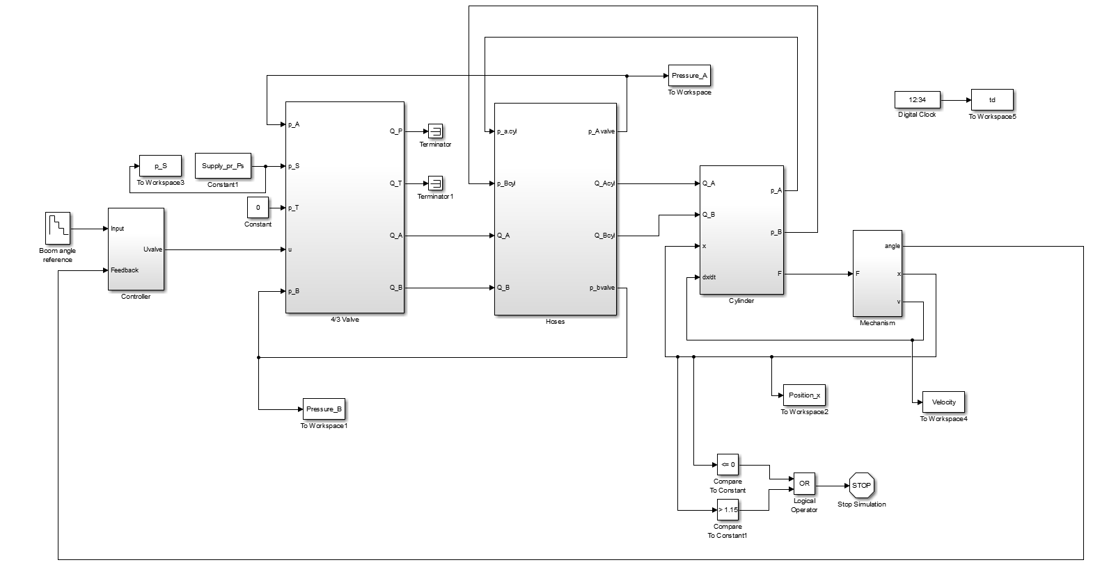

*Figure 1: Layout of system modelled*

The supply pressure and the input from the controller serves as an input to the modelled system. The 4/3 direction control valve signifies 4 ports namely P(supply), T(tank), A (chamber A of cylinder) and B (Cylinder chamber B) and 3 positions (-1,0,1). The hoses serve as a transport medium for the fluid from valve to cylinder chambers. The pressure of the fluid flow inside the hydraulic cylinder actuates the motion of the piston which generates a force for the mechanism to work.

The modelling is done in 3 steps:

* Modelling of individual components
* System verification
* Controller tuning

## MODELLING OF INDIVIDUAL COMPONENTS

* Valve Modelling

The valve modelling consists of **Valve Dynamics, Relative opening and flow paths.** The possible combination of the valve PA-BT and PB-AT

* Valve Dynamics

The **valve dynamics** consists of a saturation, transport delay and a second order transfer function. Saturation in needed along with second order transfer function because of possible overshoot. Delay function is an important parameter for on/off valve as it can be different for opening and closing and depends on different pressure levels. It is modelled using data3 of valve data.

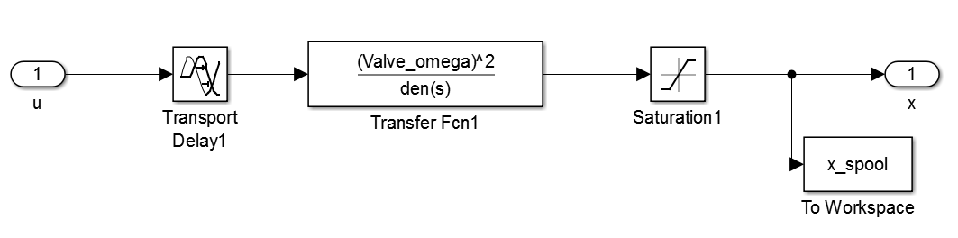

*Figure 2: Valve dynamics*

M-script for valve dynamics

%Valve Dynamics

%2nd order transfer function

Valve.secondorder_delay = 0.03;

Valve_omega = 40.5;

Valve_eta = 0.989;

* Relative Opening

The **Relative opening** serves as a bridge between spool position and flow rate. Here it is modelled using look up tables. The data points for look up tables are obtained from graphs which are plotted as spool position vs volume flow rate for individual combination such as PA-PB-AT-BT from data 1 and 2 of valve data. It is observed from the possible combinations of PA and PB the graphs show a gradually increasing exponential curve hence the volume flow rate is divided by the maximum valve such as (QA/maxQA). On the other hand, BT and AT is divided by the minimum valve of the volume flow rate such as (BT/minBT) due to decreasing exponential curve. The reason of dividing with the maximum/minimum valve was to set the maximum limit to unity so that valve from the graphs can be computed easily. Leakage is considered because of hydraulic fluid is flowing in the pipes. The outputs are the relative openings of four different ports PA, TB, PB and TA, which are connected to the input ports of the orifice.

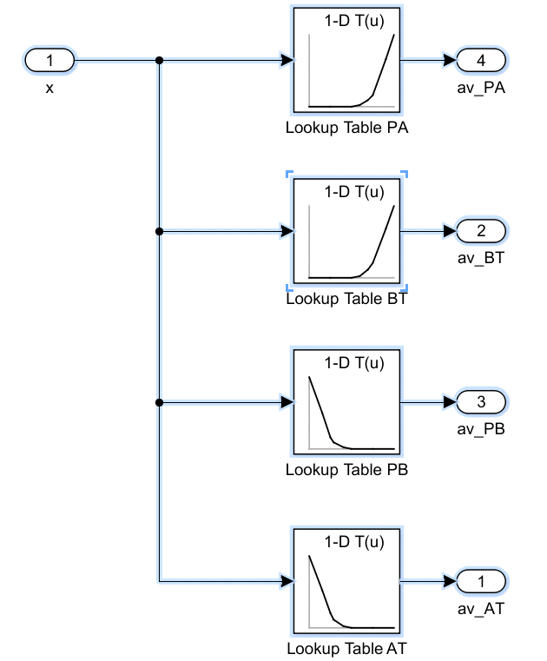

*Figure 3: Relative opening*

M-Script for relative opening

%RELATIVE OPENINGS

%Look-up Tabel PA

figure(1),clf

plot(data1.SpoolPOS, data1.QA/max(data1.QA))

xlabel('spool position PA'); ylabel('flow QA')

Valve.lookupopenPA = [5.86e-4 5.86e-4 5.86e-4 0.0329 0.1003 0.1600 0.6635 1];

Valve.lookupspoolPA = [-1 -0.5 0 0.2 0.4 0.5 0.8 1];

%Look-up Tabel PB

figure(3),clf

plot(data2.SpoolPOS, data2.QB/max(data2.QB))

xlabel('spool position PB'); ylabel('flow QB')

Valve.lookupopenPB = [1 0.4951 0.1599 0.0997 0.0324 5.86e-4 5.86e-4 5.86e-4];

Valve.lookupspoolPB = [-1 -0.7 -0.5 -0.4 -0.2 0 0.5 1];

%Look-up Tabel BT

figure(2),clf

plot(data1.SpoolPOS, data1.QB/min(data1.QB))

xlabel('spool position BT'); ylabel('flow QB')

Valve.lookupopenBT = [0.00115 0.00115 0.00115 0.0347 0.1102 0.2088 0.6821 1];

Valve.lookupspoolBT = [-1 -0.5 0 0.2 0.4 0.5 0.8 1];

%Look-up Tabel AT

figure(4),clf

plot(data2.SpoolPOS, data2.QA/min(data2.QA))

xlabel('spool position AT'); ylabel('flow QA')

Valve.lookupopenAT = [1 0.5189 0.1990 0.1118 0.0343 0.00115 0.00115 0.00115];

Valve.lookupspoolAT = [-1 -0.7 -0.5 -0.4 -0.2 0 0.5 1];

* Flow Paths

The flow paths are modelled using 4 orifice block, such as PA, PB, AT and BT. Four inputs ports are connected with the output ports of the Relative opening along with the pressure from the supply, tank, pressure at point A and B. Four orifice blocks are connected inside the flow path. Orifice blocks are used to control the pressure generally used for reduction and measure the flow rate of the fluid flowing. By reducing the pressure, cavitation formation can be controlled. The orifice inputs consist of two pressure ports one coming from either tank or supply and the other on is the pressure of either of one port namely A/B. The third input port is the relative opening of the valve connected from the relative opening. Example when the pressure of port A is considered the relative opening of connection PA is taken into account. The orifice has two output ports which are the mainly the volume flow rate. Example when the relative opening of PA is considered the two output ports are the flow rate of port A and port P. The flow from the ports P and T are connected to output ports A and B such that fluid is flowing from port P or T to ports A or B, so the output ports from P and T are terminated and volume flow from port A and B are connected to the input ports of the bidirectional cylinder

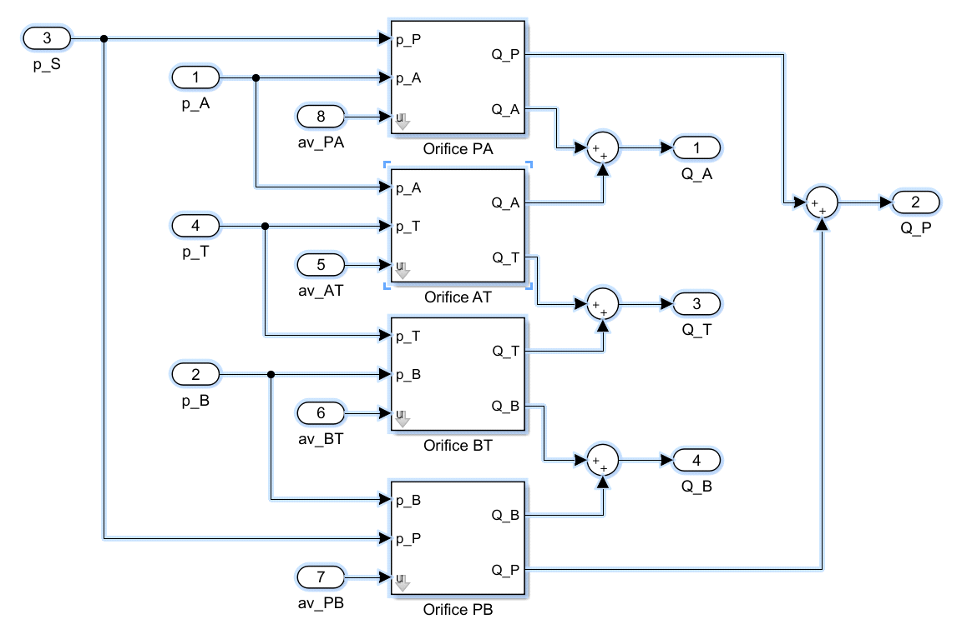

*Figure 4: Flow paths*

Calculation of nominal flow rate is done by plotting nominal pressure difference vs flowrate for each combination using data 4 and 5 of valve data.. The nominal pressure difference is given as 0.5 MPA. The corresponding flowrate for 0.5 MPA pressure difference is found from the graph.

M-script:

%Nominal flow rates

%Nominal Flow-rate PA

figure(5),clf

plot((data4.pS-data4.pA), data4.QA)

xlabel('pressure difference PA'); ylabel('flow QA')

%Nominal Flow-rate BT

figure(6),clf

plot((data4.pB-data4.pT), data4.QB)

xlabel('pressure difference BT'); ylabel('flow QB')

%Nominal Flow-rate PB

figure(7),clf

plot((data5.pS-data5.pB), data5.QB)

xlabel('pressure difference PB'); ylabel('flow QB')

%Nominal Flow-rate AT

figure(8),clf

plot((data5.pA-data5.pT), data5.QA)

xlabel('pressure difference AT'); ylabel('flow QA')

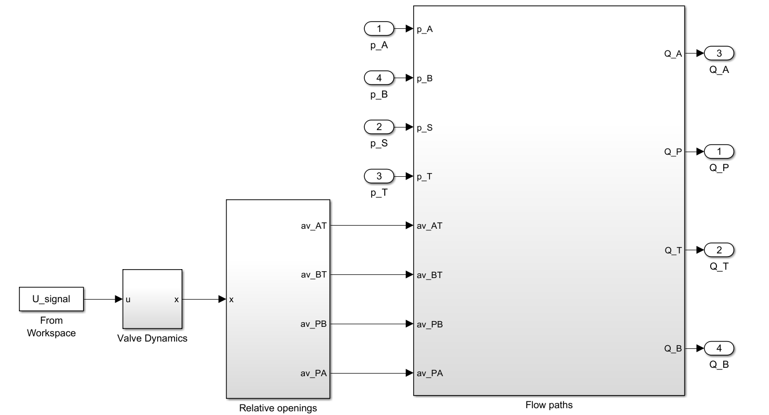

*Figure 5: 4/3 valve*

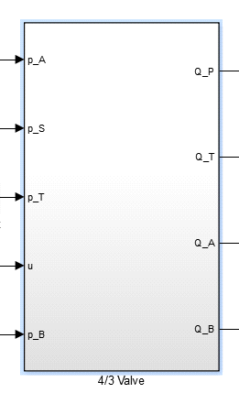

*Figure 6 Subsystem of 4/3 valve*

* Actuator Modelling

The cylinder is a bi-directional cylinder with chamber A and B, it is modelled using 2 volume blocks representing individual chambers respectively. The cylinder is modelled using the volume and its derivative equations. If there is an inflow to chamber A from valve through hose there will be outflow from chamber B to valve through hose. Since the cylinder by itself cannot generate position and speed , an initial force is given as an input to the mechanism by the cylinder as a result of which speed and position of the plunger of the cylinder can be computed. The cylinder consists of friction model which is modelled as follows.

2.2.1 Friction Model

A subsystem of **friction** is considered where the input port velocity of the cylinder plunger and the output is the frictional force. Friction is considered inside the cylinder because completely smooth surface cannot exist and there is relative movement of the surface. Static friction Fs and coulomb friction Fc is considered where static friction is 5-10% of the maximum force exerted by the hydraulic cylinder and coulomb friction is 10-40% smaller than static friction. Normally the static frictional force holds the cylinder load.

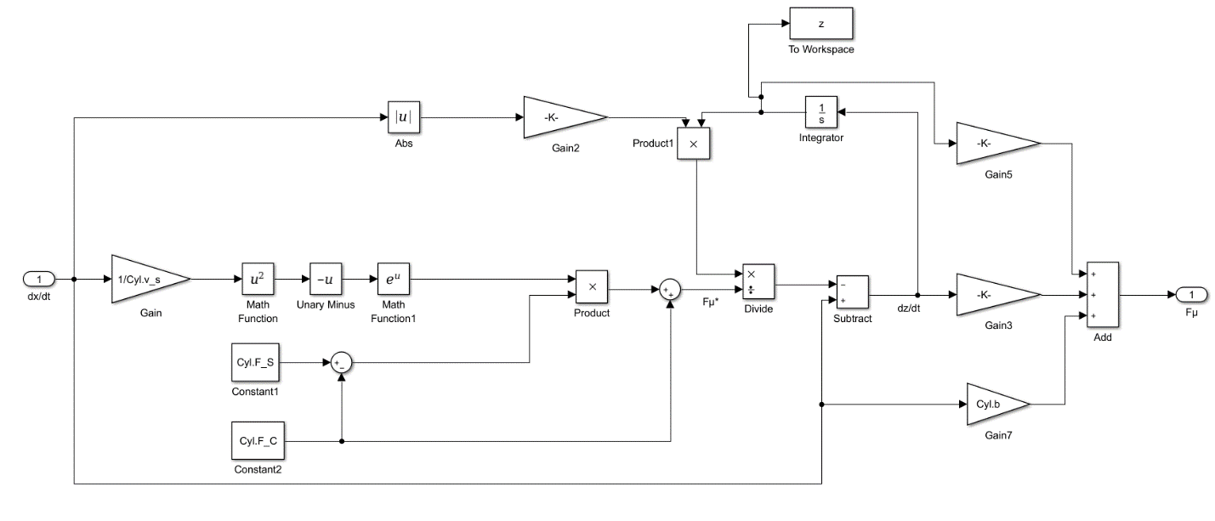

*Figure 7: Friction Model*

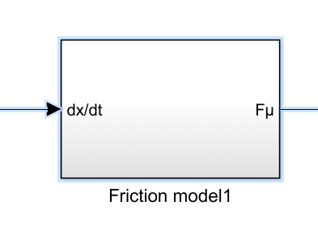

*Figure 8:Subsystem of friction model*

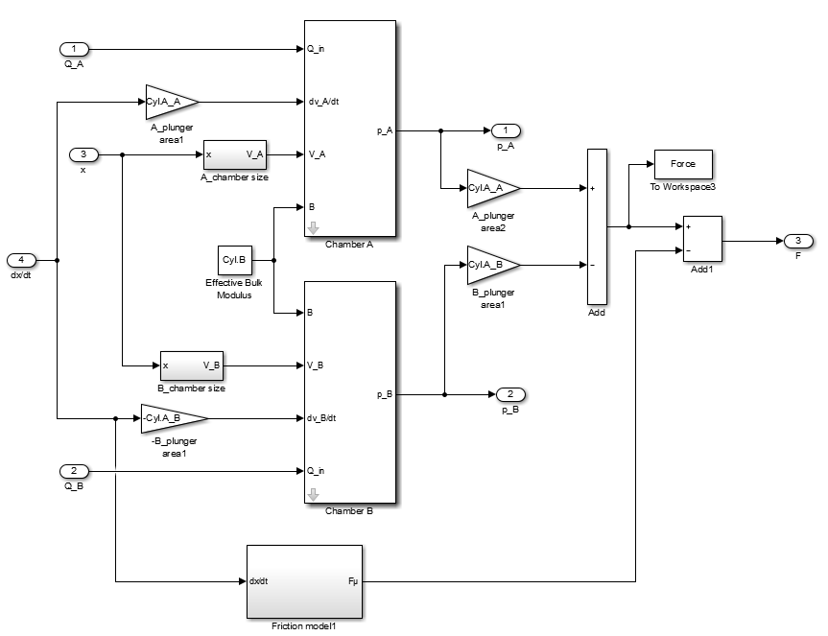

*Figure 9: Cylinder with Friction model.*

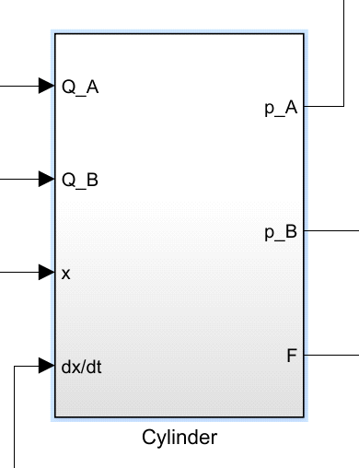

*Figure 10: cylinder subsystem*

* Hoses

Hoses are modelled using 2 volume and 2 orifice blocks. The combination of one volume and one orifice block acts as a hose to port A and other combination to port B. The inputs are the volume flow rate coming from valve port A and port B and pressure at volume blocks A and B serve as input to orifice which transfers flow to cylinder.

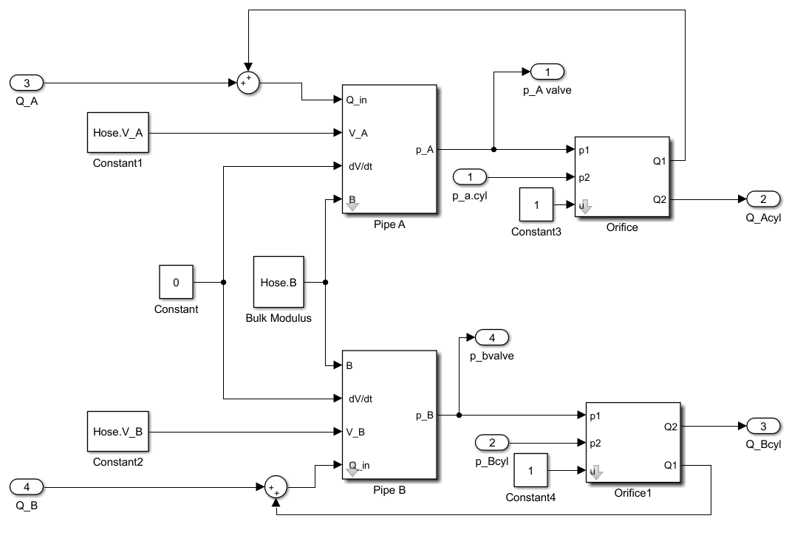

*Figure 11: hose*

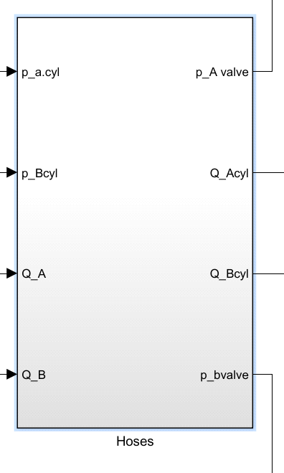

*Figure 12: subsystem of hose*

* MECHANISM

**Mechanism** consists of an excavator arm system which is actuated by the force F given by the hydraulic cylinder. The main components of the excavator are BOOM, ARM and BUCKET. The movement of the boom and the bucket is fixed with respect to the arm. The movement of the arm is generated by the movement of the arm cylinder.

The Machine environment has a gravity vector along negative of y-axis since the gravitational force act’s in downward direction. The boom of the excavator is connected with the Machine environment with the help of weld joint. Since the Boom is attached with the ground so the interia is consider to be negligible. It has 4 ports, first CG(center of gravity)is considered to be in the origin as it is connected to the ground,CS1(reference point) it also lies on the origin, CS2 port is connected to the Arm cylinder joint at point A,CS3 port is connected with the Arm joint. A body sensor is joined between the Boom and the Arm cylinder position A which senses the position and velocity of the cylinder position at A. A revolute joint is placed between the Boom and Arm. The Arm movement is caused by the torque which is generated by the Arm cylinder by the help of revolute joint. The Arm has 5 ports. CG, CS1, CS2, CS3 and CS4.The CS1 port is taken as a reference point so its co-ordinates are zero, all the ports are measured with respect to CS1. CS3 port is connected with Bucket joint and CS4 port is connected with Arm cylinder joint at point B. Similar to Body sensor in Boom joint the another sensor is attached between Arm and Cylinder position B which senses the velocity and position at position B. The torque produced by the Arm cylinder rotates the revolute joint which is sensed by joint sensor making the Boom rotate at an angle known as Mean_JointAngle.

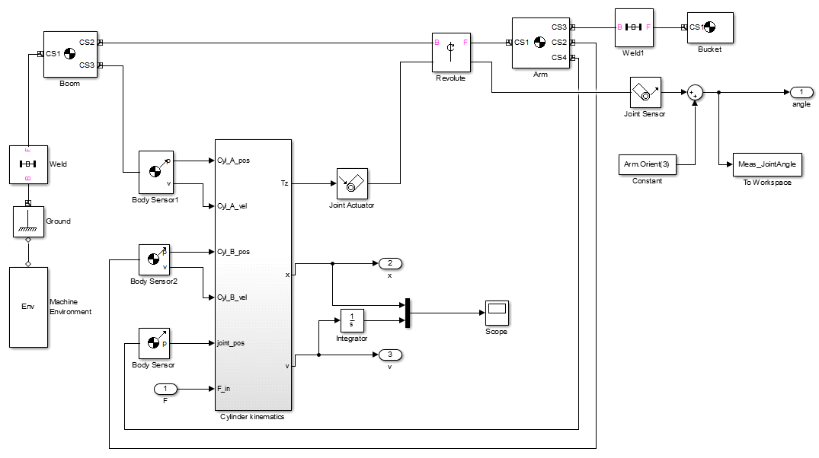

*Figure 13:Mechanism*

* Sim Mechanics

The **Arm cylinder** consists of a separate subsystem which includes six input ports and three output ports. The input ports are Force caused by the movement of bi-directional cylinder, velocity and position of cylinder at point A&B respectively and Joint position. The output ports are displacement, velocity and torque. Inside the subsystem we have two separate subsystem to calculate the position, velocity and the second to calculate the torque generated by the cylinder.

* Cylinder Kinematics

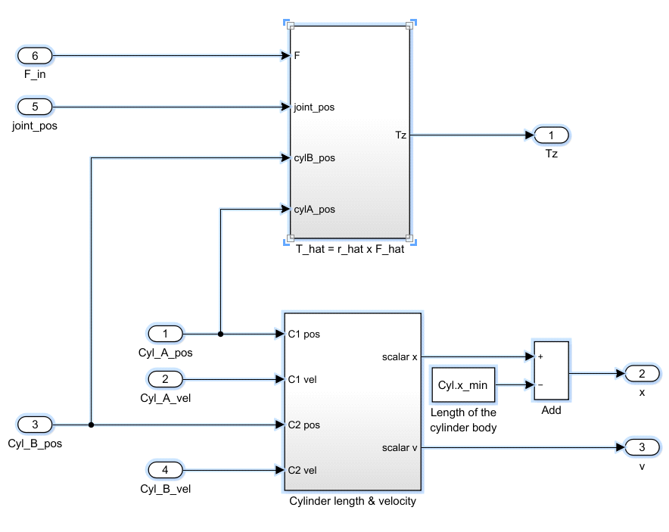

*Figure 14: Cylinder kinematics*

The necessity was to calculate the stroke length of the Arm cylinder and to observe the velocity at which the cylinder is operating both in upward and downward direction. The upward direction is considered as position B of the cylinder and the downward as position A. It is observed from the graph obtained from scope that the velocity of the cylinder at the upward direction is positive. The position of the cylinder is defined by a function {where u(1),u(2) and u(3) are positions in x, y and z axis respectively}which calculate the absolute valve of its displacement. When this function is divided by the difference in cylinder position at point A and B it forms a unity vector (with specific direction). The dot product of unity vector with the difference in velocity of position A&B helps us to find the magnitude of radial velocity of the cylinder.

To difference between position A and B of the Arm cylinder when normalized by a normalizing vector results unity vector (with a specified direction) at which the force is applied. The cross product of the force and the difference between the joint position and the position B of the cylinder gives a torque in the direction of the applied force.

### VERIFICATION OF THE MODEL

The system is verified for data 4 and data 8 of system data. The friction parameters are tuned to match the simulated results with measured results by plotting position, velocity, boom angle, pressure,etc with time.

* Verifying the system using DATA 4
* POSITION

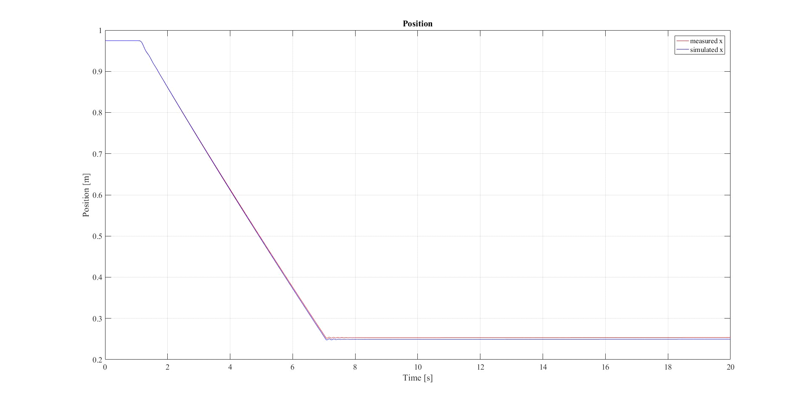

* VELOCITY

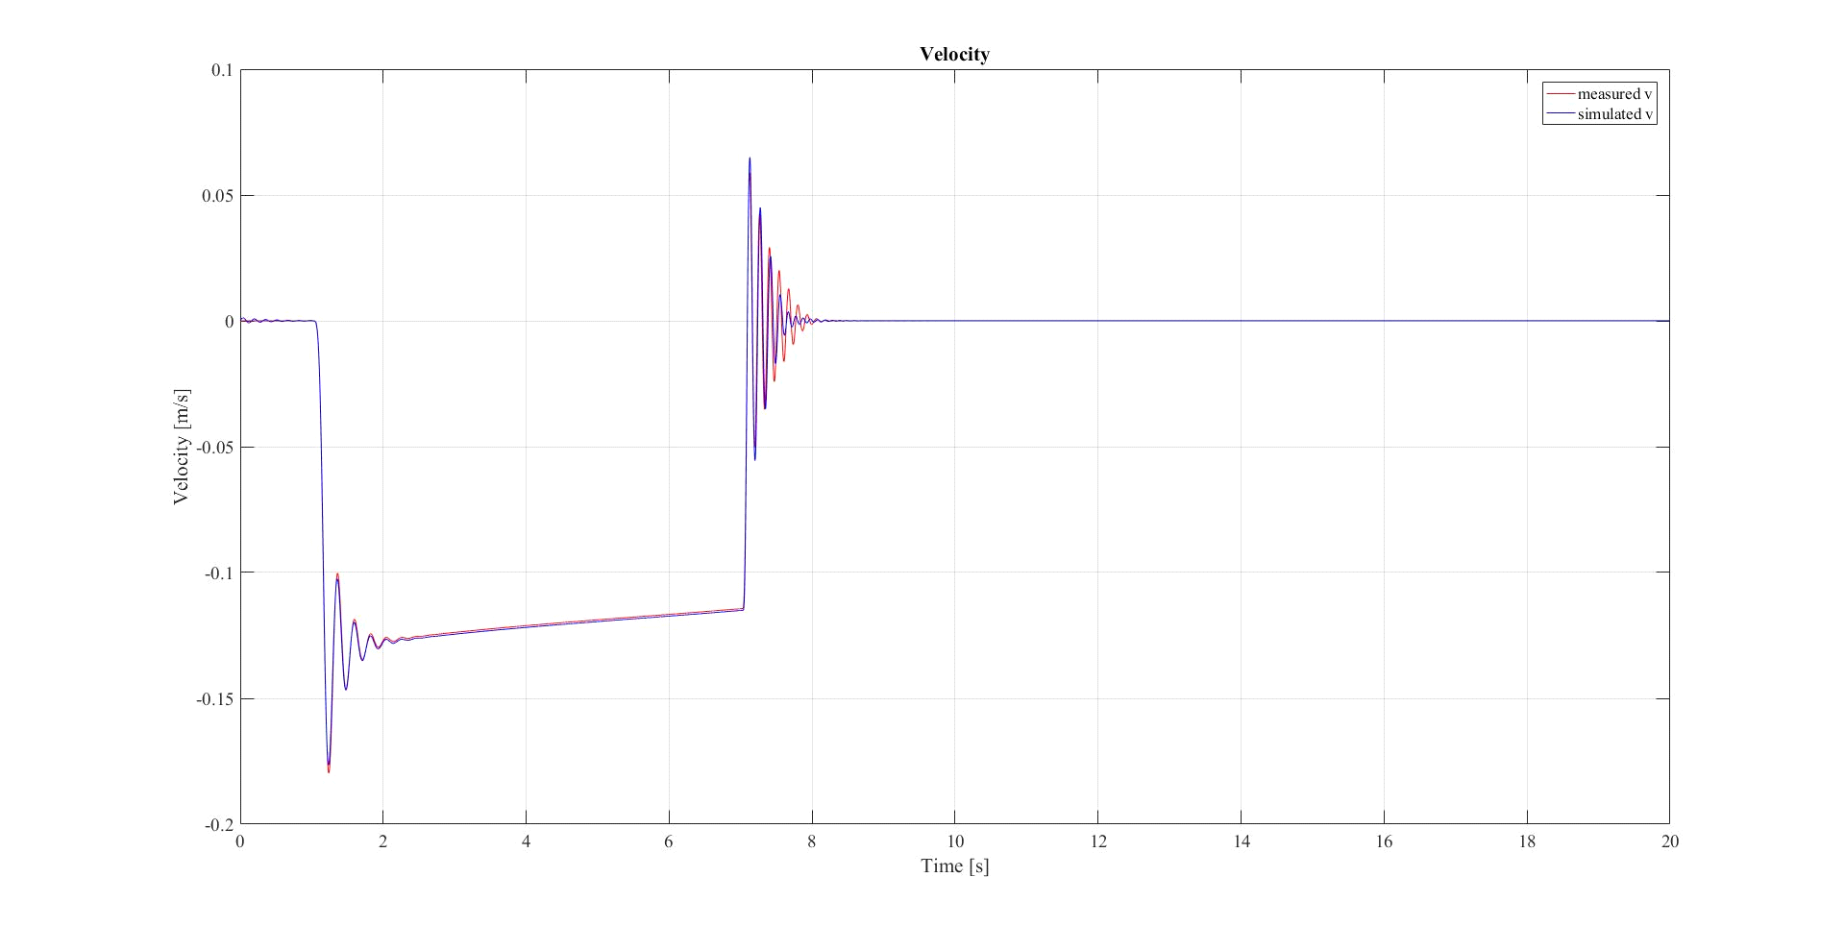

* FORCE

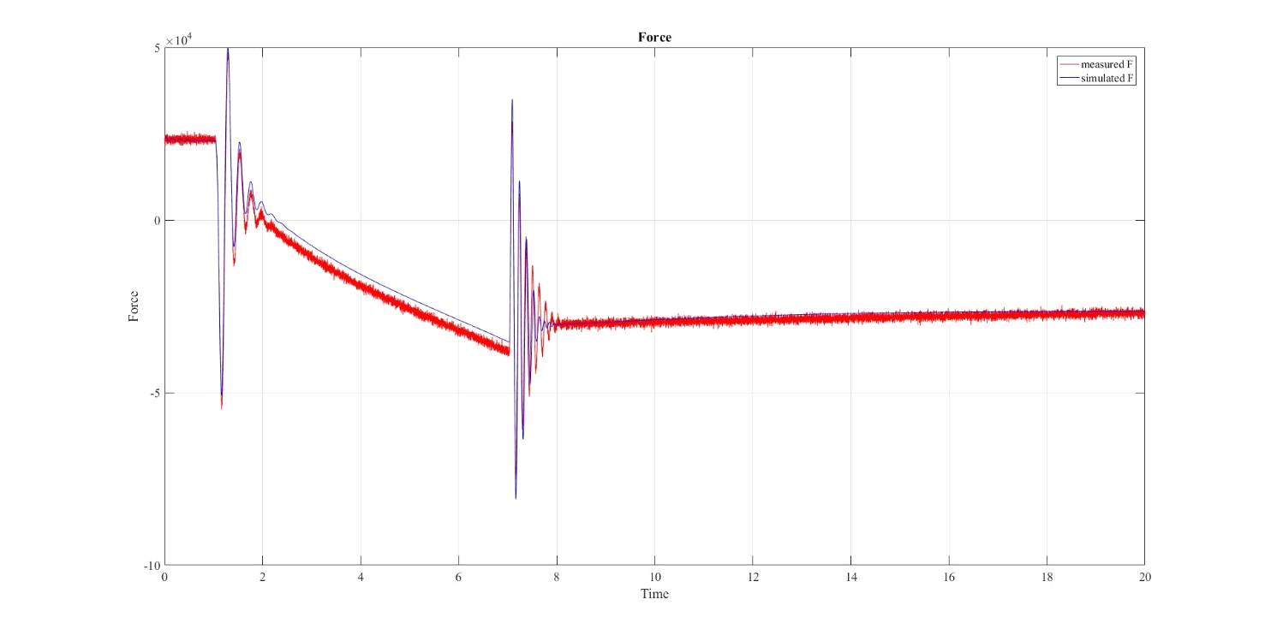

* Pressure

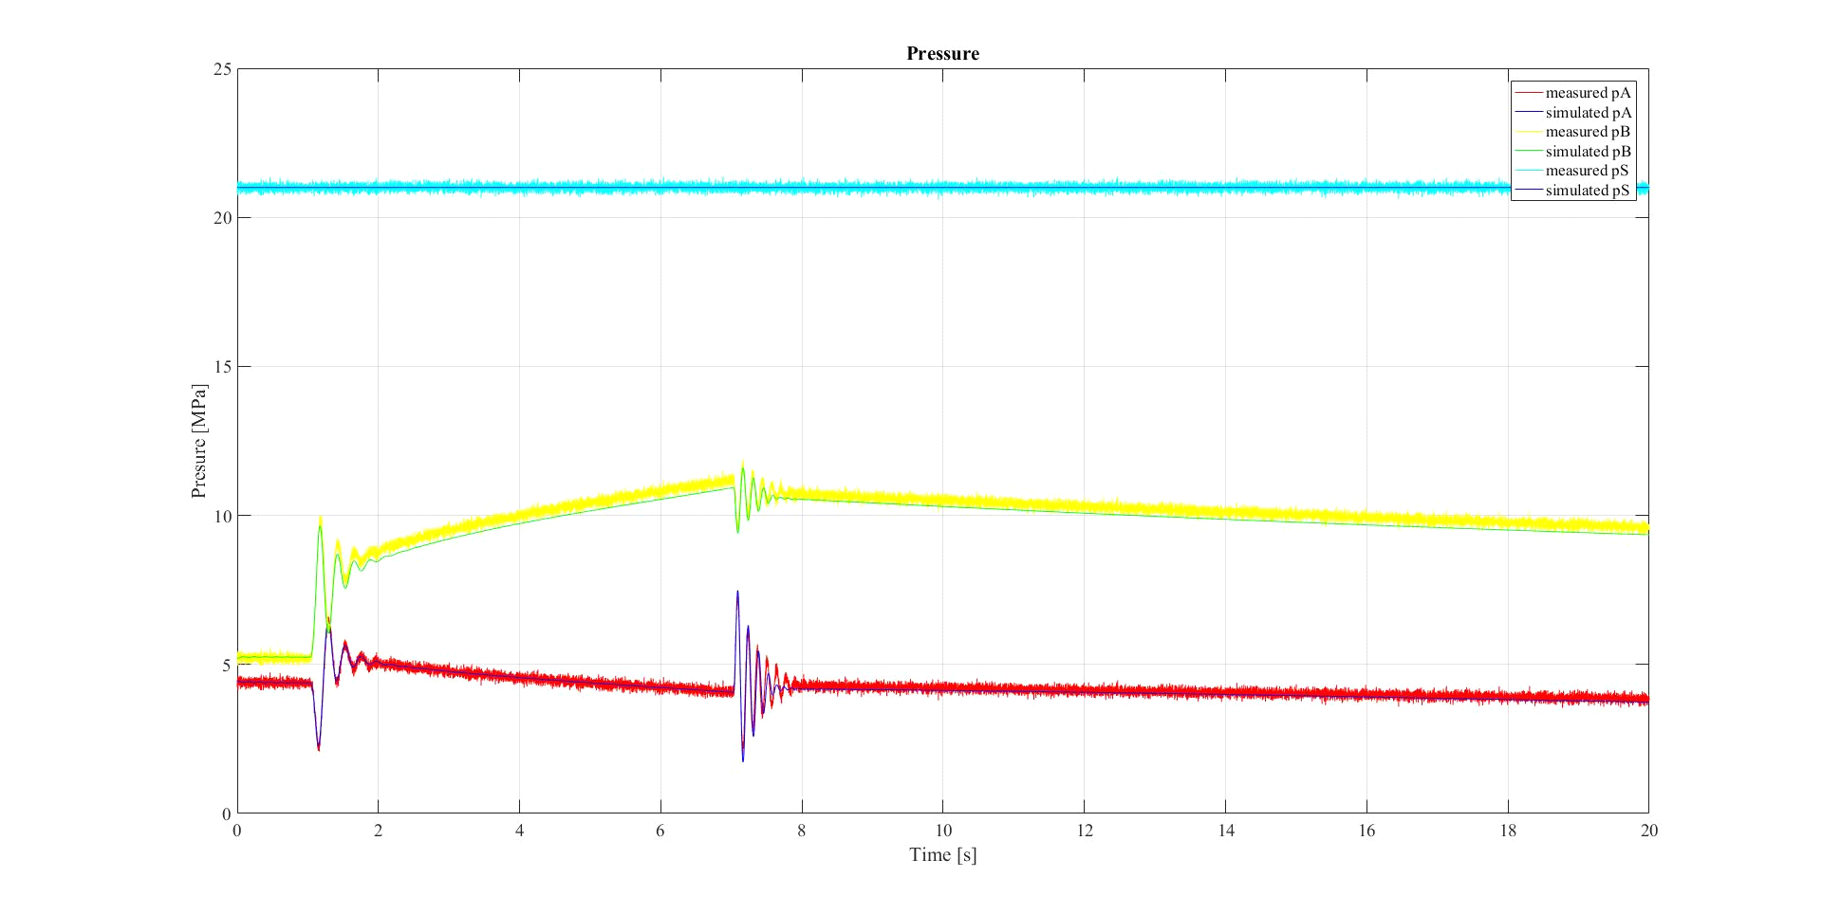

* BOOM ANGLE

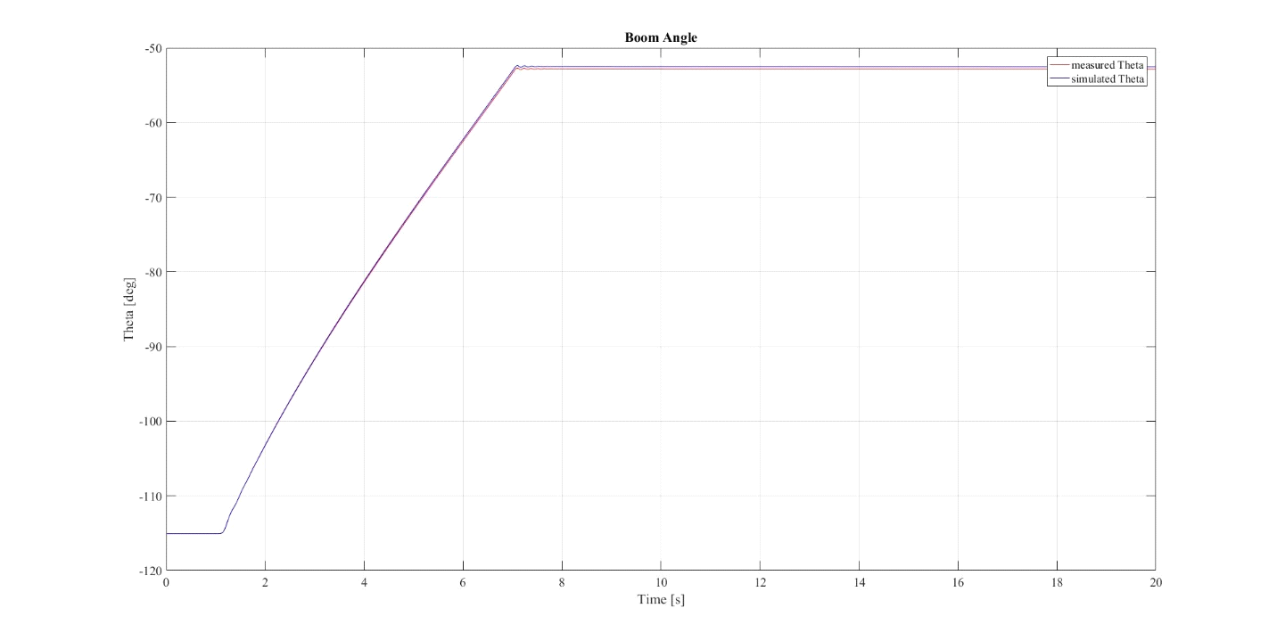

* VALVE

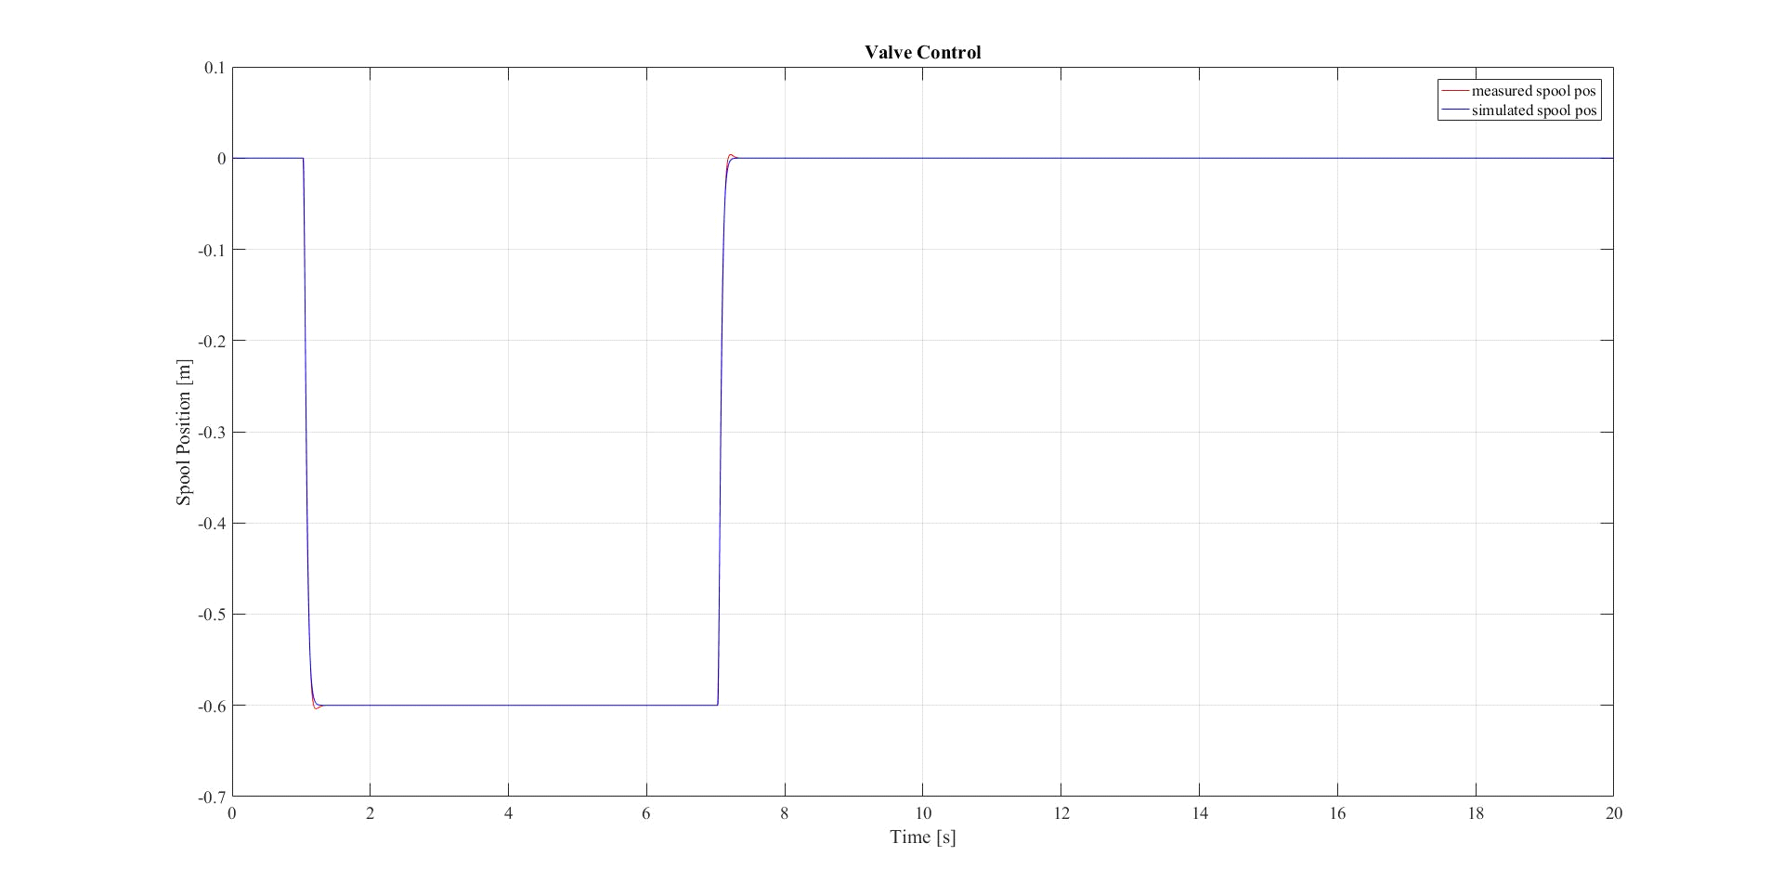

* Verifying the system using DATA 8
* POSITION

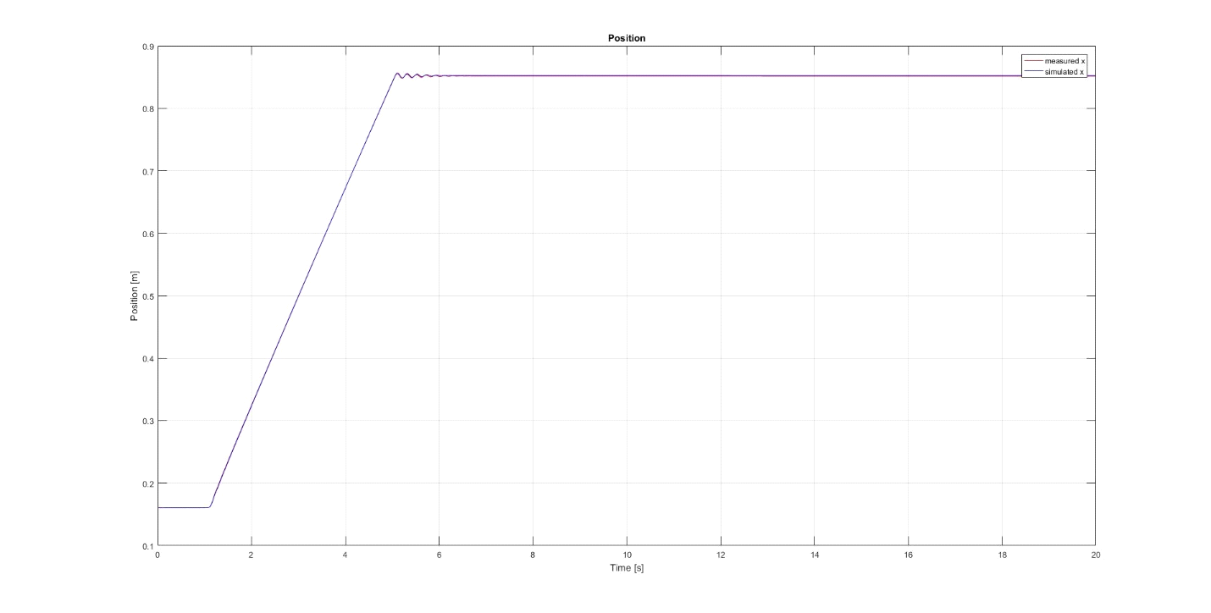

* VELOCITY

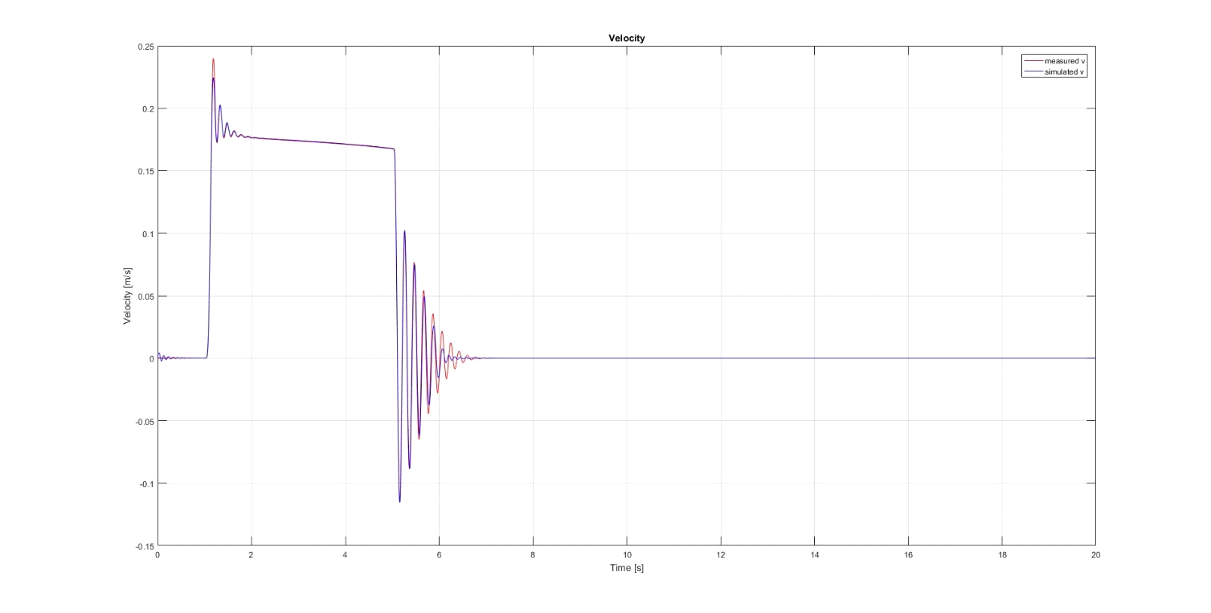

* Force

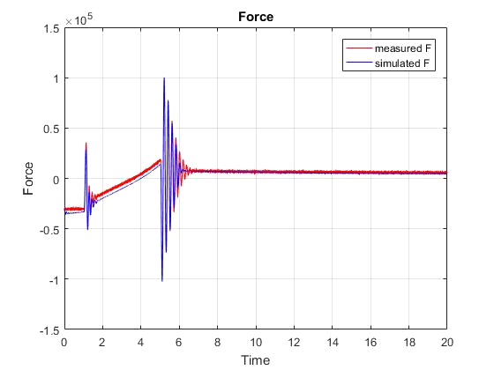

* PRESSURE

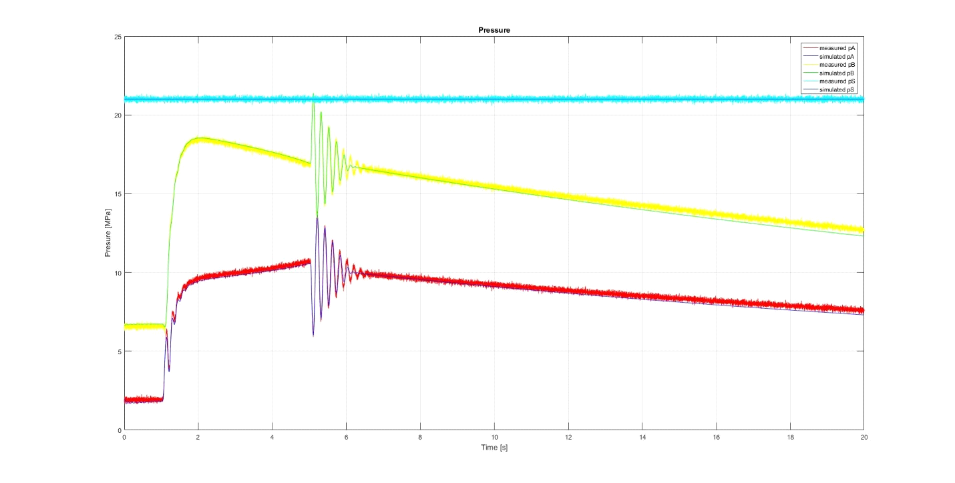

* Boom Angle

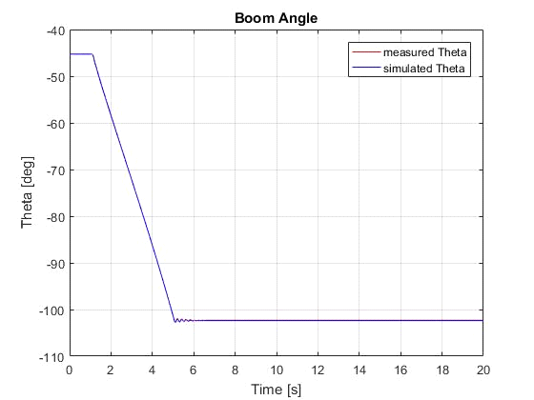

* Valve

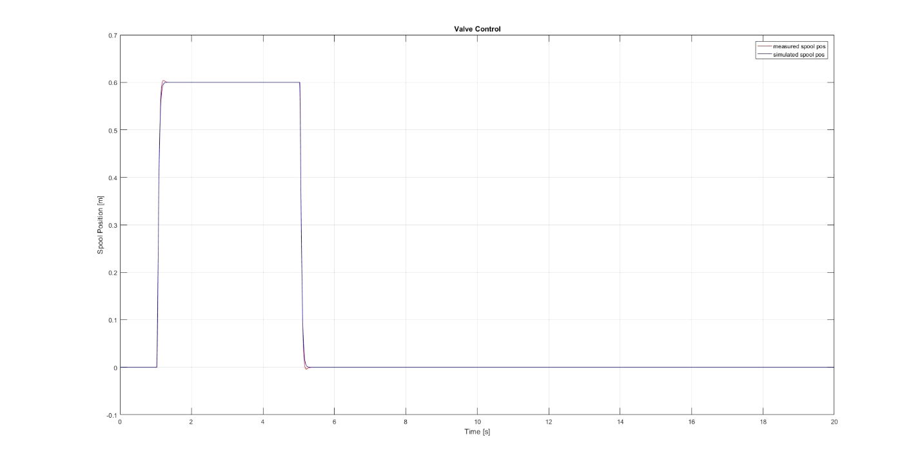

From the above graphs its evident that the simulated values are in good response with the measured values. Hence the verified system with system data can be further implemented along with the controller.

#### CONTROLLER TUNING

Here the P-controller is used along with feedback for controller tuning. The input is the boom reference angle.

* Finding p- gain

The p gain is found by using Ziegler-Nichols method. The input is the stepwise angle reference. The smallest gain for which the boom angle continues to oscillate is called the critical gain. 0.5 times of critical gain is optimal gain.

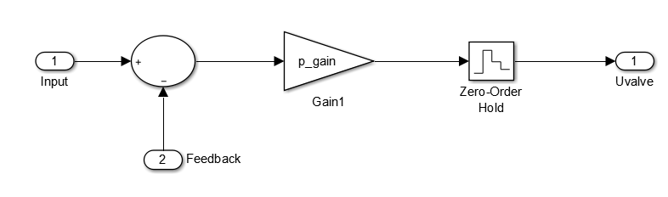

It is done in two steps

* Step input of -50 to -115

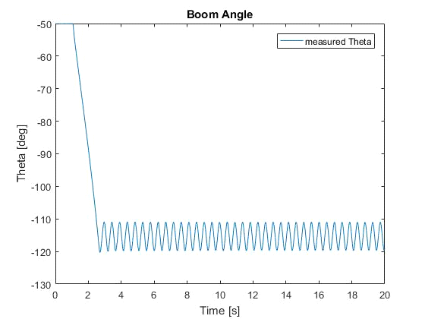

Here the critical gain is -0.2804 hence optimal gain is -0.14025.

* Step input of -115 to -50

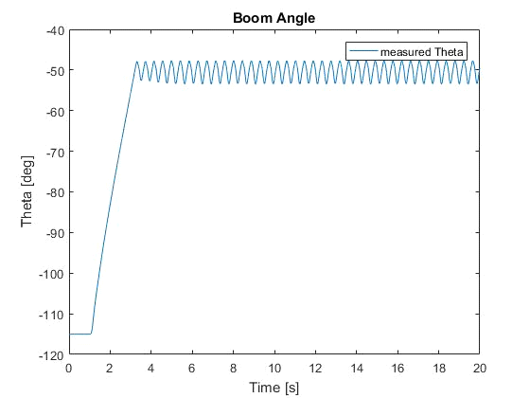

Here the critical gain is -0.525 hence optimal gain is -0.14025.

Here the smallest gain is selected for stability in both conditions.

Now the repeating sequence stair acts as input and the following graphs are obtained.

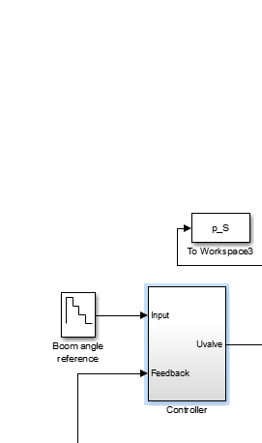

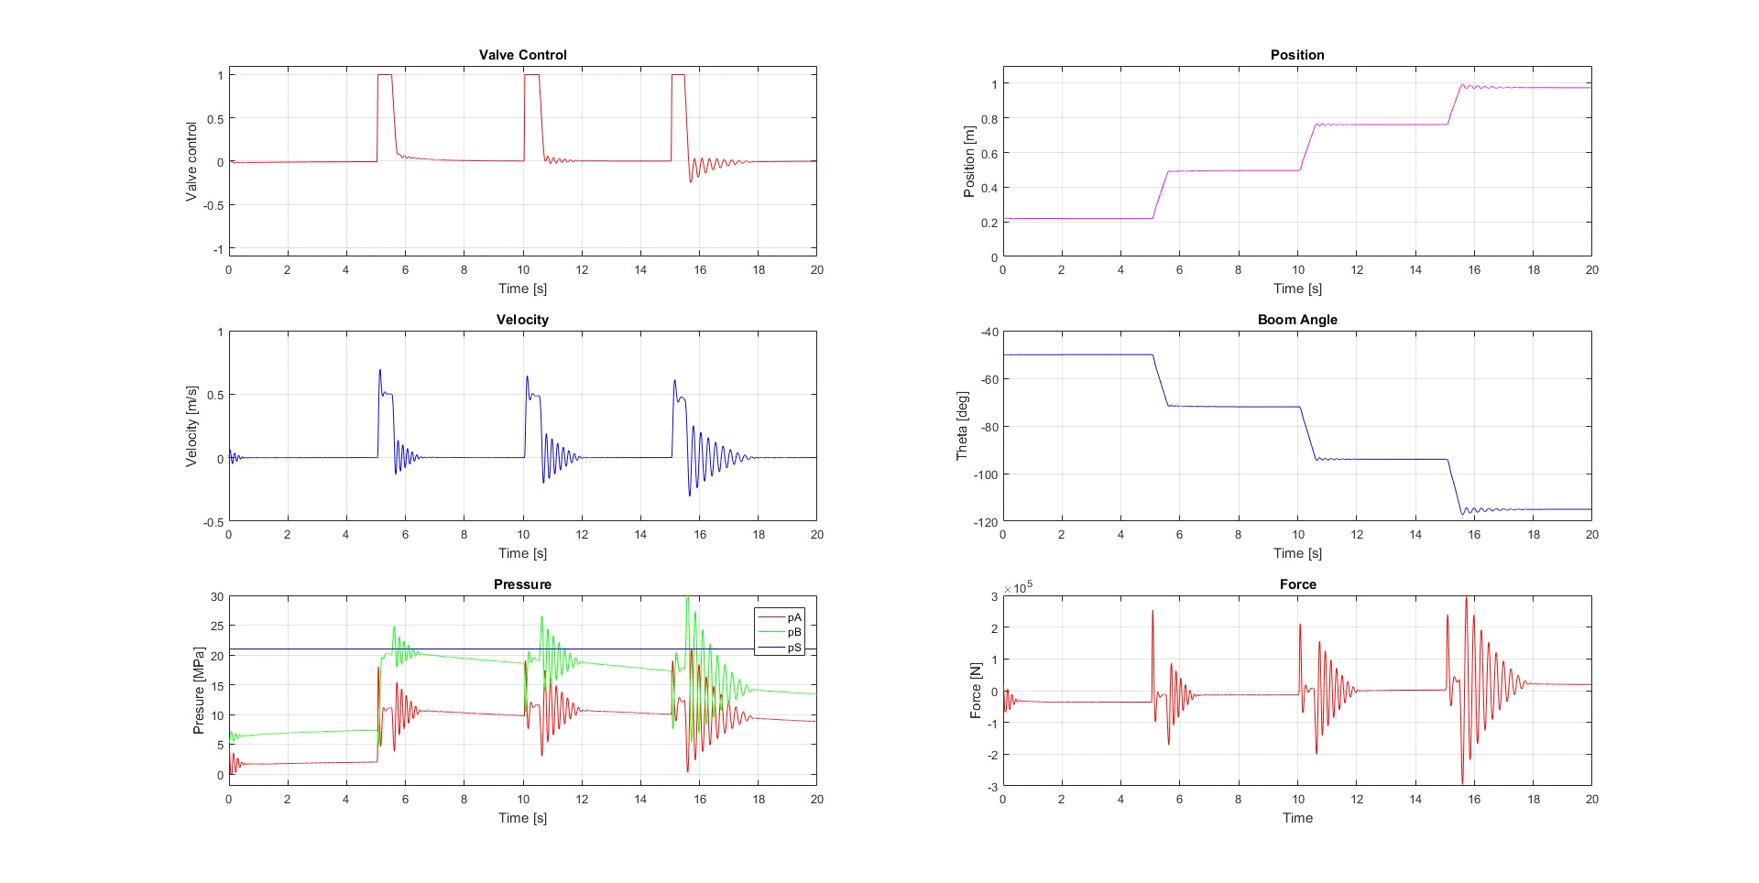

##### CONCLUSION

1. The friction parameters were tuned for the simulated results to match the measured results. The static and columbic friction values play an important role in matching the plots. Increasing the friction forces damps the system which reduces the oscillations but keeping them low increases the difference between measured and simulated results.
2. The leakage values in the relative opening play important role in maintaining the pressure response as per measured values.
3. The velocity of the arm cylinder should be positive when it is moving in the upward directional.
4. In valve dynamics a second order transfer is preferred over first order to get a good simulated result.